

**Project - Harvard Business Publishing Education**

**PJM6025 Spring 2024 - Project Scheduling & Cost Plan**

**Challenges and Prospects at Delphi Printers & Peripherals – A Stimulation Case Project**

By Dia Khosla

Northeastern University, College of Professional Studies   
PJM6025 80631 Project Scheduling & Cost Planning

**Prof. Samad Aidane**

**June 26, 2024**

***Challenges and Significant Strategies w.r.t Trade-off in Simulation Project at Delphi Printers & Peripherals***

1. **Challenges:-** As a Project Manager at Delphi Printers & Peripherals, I had to juggle between how much work my team could handle when we could finish it, and what the budget management team allowed us to spend. Sometimes, ensuring we delivered a great product required adjusting the schedule and changing the budget from what management had planned. Each time we decided to add more features to enhance competitiveness, it also meant finding additional resources (staffing and outsourcing) to manage potential cost overruns, which wasn't always easy. Keeping the team happy and motivated was also a significant challenge. I had to ensure everyone had enough work without feeling overstressed, especially as deadlines approached and our competitors were launching similar products. Lastly, handling unexpected changes or market shifts was tricky. We had to continuously adjust our plans to ensure we stayed on track with our goals and could launch our product ahead of competitors.
2. **Strategies and Trade-off**

**Scenario A:** Initially targeted Level 2 scope to align with competitor launch timelines. Later expanded to Level 4 to enhance competitiveness, focusing on key features like print-from-mobile and advanced printing capabilities. Further, implemented buffer time for potential delays and managed milestones. Also, as a Project Manager, I had to optimize team composition and skill levels to balance costs and productivity and utilizing outsourcing strategically for specialized tasks. Scheduled regular meetings for coordination and morale-building activities. Managed overtime to meet milestones. **II. Decision/Tradeoff Impact:** Opting for Level 4 scope impacted schedule adherence due to increased complexity, leading to a delay beyond the initial target. This decision was critical for enhancing product competitiveness but required careful resource management.

**Scenario B:** Worked on **e**xpanding scope strategically to differentiate the product from competitors, focusing on customer-centric features and advanced functionalities on Delhpi printer. Managed schedule tightly, prioritizing critical milestones to ensure timely completion and market entry. Balanced team composition and skill levels to optimize productivity. Leveraged outsourcing for specialized components to control costs. Further, emphasized clear communication, recognition, and team-building activities to maintain high morale and foster a positive work environment. **II. Decision/Tradeoff Impact:** The decision to expand scope required careful resource management to avoid cost overruns and schedule delays. It ensured the product met market demands but necessitated tradeoffs in resource allocation.

**Scenario C:** Maintained minimal scope to meet baseline expectations effectively. Focused on core functionalities while ensuring quality and cost-effectiveness. Implemented a streamlined schedule to deliver on time and within budget constraints. Prioritized efficiency in task management and timeline adherence. Utilized lean staffing with moderate skill levels to control costs while meeting project objectives. Minimized outsourcing to maintain control over project dynamics. Promoted task efficiency and managed stress levels by maintaining a balanced workload. **II. Decision/Tradeoff Impact:** Maintaining minimal scope helped in meeting budget and schedule goals efficiently. However, it required careful tradeoffs in feature completeness and market competitiveness.

**Score Board Results for Delphi Printers & Peripherals**

Demonstrating the scores received from the three scenarios (A, B, and C), I utilized trade-offs between schedule, scope, and resources strategically. I worked on refining strategies in each scenario to ensure successful project delivery without compromising on quality, adhering to schedule requirements, and meeting market demands effectively.

***Scenario A :-***

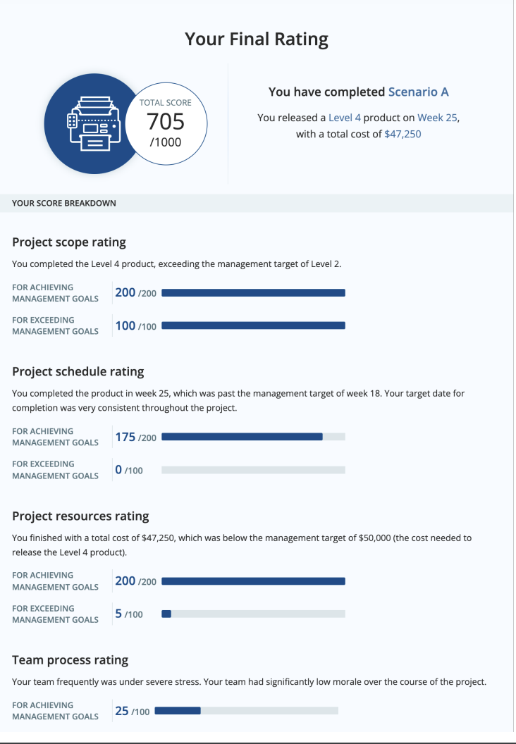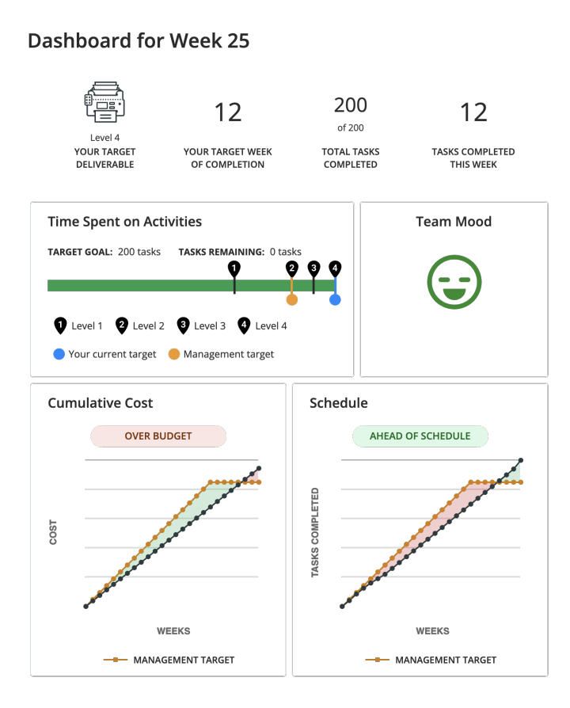

**Scenario B :-**

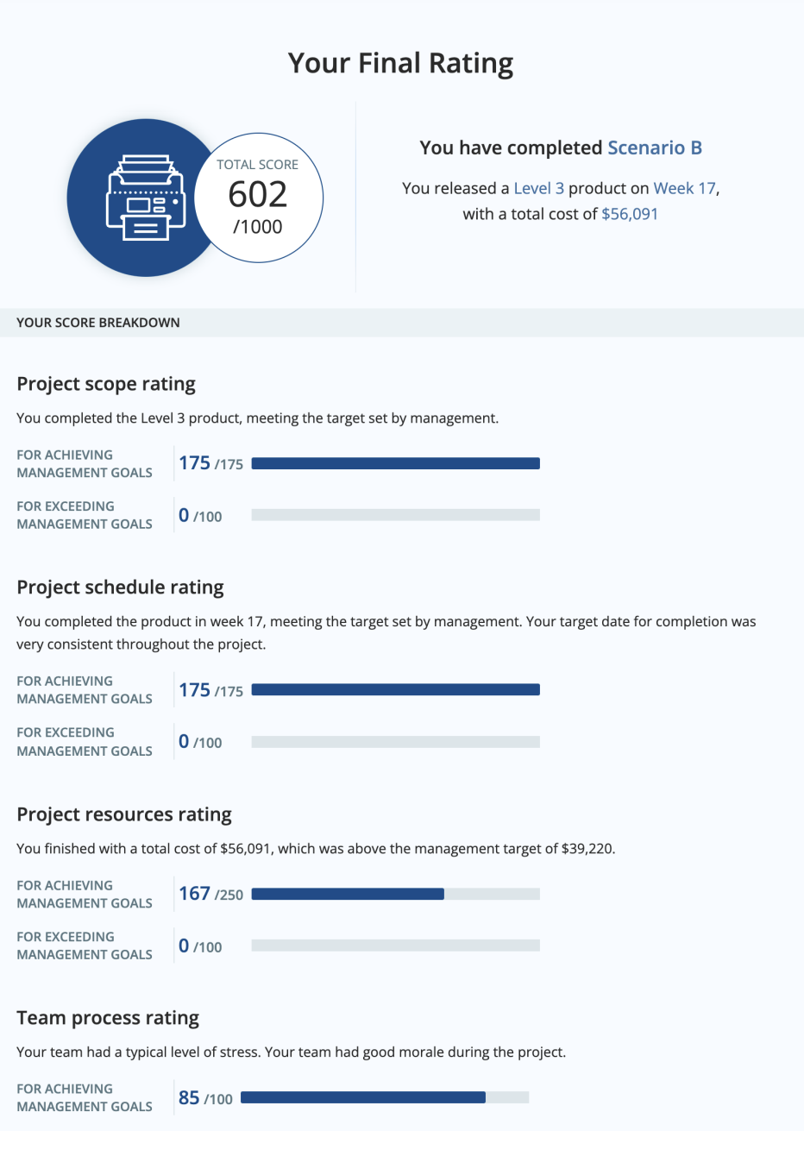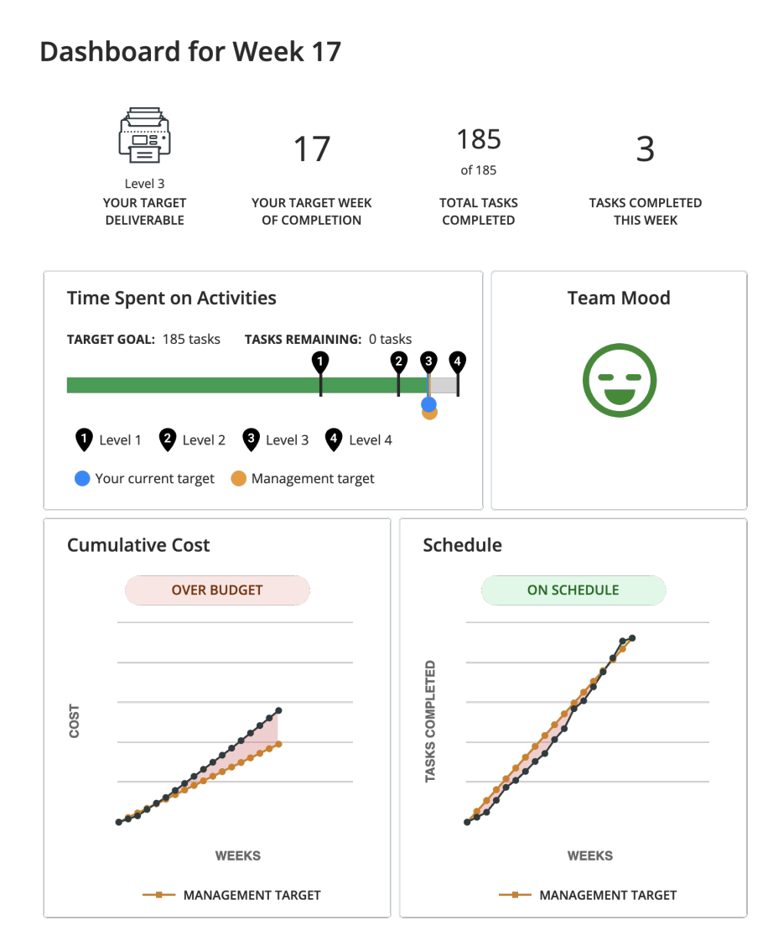

**Scenario C :-**

